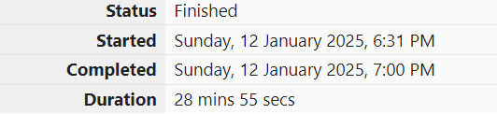

ROLL NO.:241801281

NAME: SUJITHA NEELAKANDAN VIGNESHWARI

WEEK 11-01

1.OBJECTIVE:

Your task is to determine if given strings A and B are compatible.

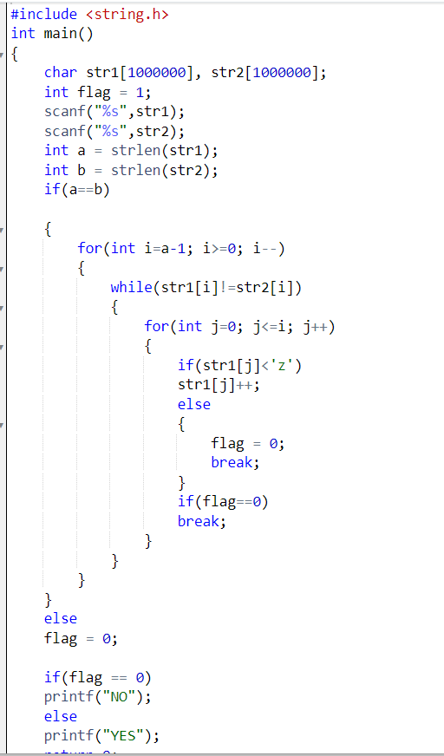 CODE:

OUTPUT:

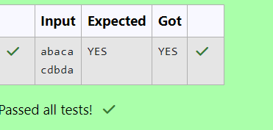

2.OBJECTIVE:

You have to print the length of Manny's password and it's middle character.

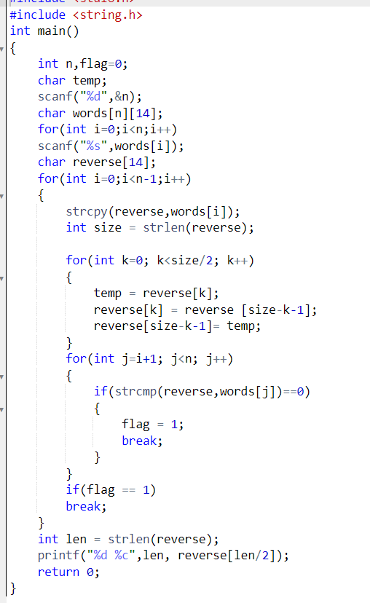CODE:

OUTPUT:

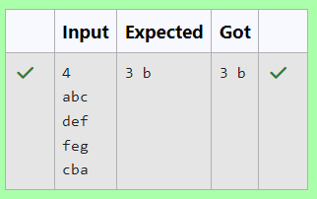

3.OBJECTIVE:

Joey has assigned points to all the restaurants, but can't figure out which restaurant satisfies Chandler's criteria. Can you help him out?

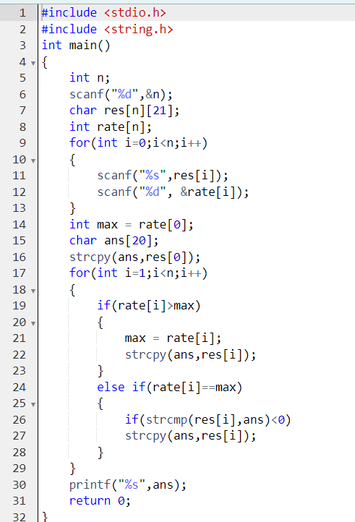CODE:

OUTPUT:

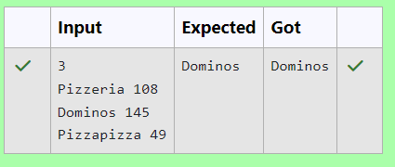

4.OBJECTIVE:

You are given a string "S" and you have to determine whether it is Valid mobile number or not. Mobile number is valid only if it is of length 10 , consists of numeric values and it shouldn't have prefix zeroes.

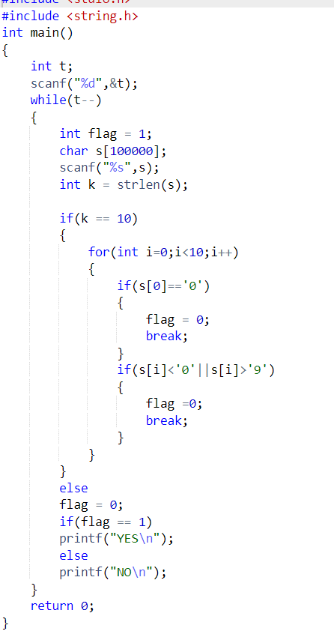CODE:

OUTPUT:

